VILLAGE OF COXSACKIE
BOARD MINUTES
October 15, 2019

Mayor Mark Evans called the Board Meeting to order at 7:00 p.m. Present were Trustee Donald Daoust, Trustee Joseph Ellis and Trustee Dianne Ringwald. Trustee Stephen Hanse was absent.
A motion to approve the minutes from the September 9, 2019 Board Meeting was made by Trustee Daoust and seconded by Trustee Ringwald. Trustee Daoust voted yes. Trustee Ellis voted yes. Trustee Ringwald voted yes. The motion carried.

A motion to approve the minutes from the September 16, 2019 Special Meeting was made by Trustee Ellis and seconded by Trustee Daoust. Trustee Daoust voted yes. Trustee Ellis voted yes. Trustee Ringwald voted yes. The motion carried.
Liaisons & Board Reports

Mayor Evans stated that Resolution No. 132019 on tonight’s agenda is in relation to the Village Board submitting their stipulations for the Hecate Energy solar project. The Village Board has been relying on counsel for guidance during this process. The areas in which the Village is submitting stipulations are 3-Location of Facilities, 4-Land Use, 9-Alternatives, 12-Construction, 15-Public Health and Safety, 24-Visual, 27-Socioeconomic Effects, 29-Site Restoration and Decommissioning, and 31-Local Laws and Ordinances. The counsel reviewed all of the stipulations and gave recommendations on these areas, and the Village Board has decided to act on them.
Mayor Evans stated that the Village Board will dispense with the reading of the monthly department head reports, but that all monthly reports are on file with the Village Clerk.
Motions & Resolutions
A motion to approve the request received from Patty McIntyre of 87 Washington Avenue asking to have her penalties removed from her water/sewer account in the amount of $ 25.05, due to the fact that her check got lost in the mail and she has an excellent payment history was made by Trustee Ringwald and seconded by Trustee Ellis. Trustee Daoust voted yes. Trustee Ellis voted yes. Trustee Ringwald voted yes. The motion carried.
A motion to approve the request received from Jim & Bonnie McKenny of 50 Washington Avenue asking to have their penalties removed from their water/sewer account in the amount of $ 28.41, due to the fact that they did not receive a water bill and they have an excellent payment history was made by Trustee Ringwald and seconded by Trustee Ellis. Trustee Daoust voted yes. Trustee Ellis voted yes. Trustee Ringwald voted yes. The motion carried.

A motion to approve renewing the MVP Silver 8 HDHP EPO health insurance plan for employees starting December 1, 2019 was made by Trustee Ringwald and seconded by Trustee Ellis. Trustee Daoust voted yes. Trustee Ellis voted yes. Trustee Ringwald voted yes. The motion carried.

A motion to approve the quote received from Marshall & Sterling Insurance Company for commercial insurance with a cyber coverage rider was made by Trustee Ringwald and seconded by Trustee Ellis. Trustee Daoust voted yes. Trustee Ellis voted yes. Trustee Ringwald voted yes. The motion carried.

A motion to approve authorizing Delaware Engineering to design sidewalks for Bailey Street, from Mansion Street to Peppertree Drive was made by Trustee Ringwald and seconded by Trustee Ellis. Trustee Daoust voted yes. Trustee Ellis voted yes. Trustee Ringwald voted yes. The motion carried.

A motion to approve the quote received from Maser Consulting in the amount of $ 5,000.00 to develop new written emergency plans for both reservoir dams was made by Trustee Ringwald and seconded by Trustee Ellis. Trustee Daoust voted yes. Trustee Ellis voted yes. Trustee Ringwald voted yes. The motion carried.

A motion to approve hiring Joseph Mann as Water Plant Laborer with a starting pay rate of $17.21/hr. was made by Trustee Ringwald and seconded by Trustee Ellis. Trustee Daoust voted yes. Trustee Ellis voted yes. Trustee Ringwald voted yes. The motion carried.

A motion to approve the quote received from Robert H. Finke & Sons in the amount of $2,726.88 for a 54” Bobcat Sweeper attachment for the DPW was made by Trustee Ringwald and seconded by Trustee Ellis. Trustee Daoust voted yes. Trustee Ellis voted yes. Trustee Ringwald voted yes. The motion carried.

A motion to approve the water agreement for 130 Stacy Road between the Village, Town, Flach & the homeowner Wendy Flannery, with the stipulation that no further connections will be made to this private line was made by Trustee Ringwald and seconded by Trustee Ellis. Trustee Daoust voted yes. Trustee Ellis voted yes. Trustee Ringwald voted yes. The motion carried.

A motion to approve setting aside $100,000.00 received for the Washington Avenue sidewalk reimbursement to the 14 South River Street Project fund was made by Trustee Ringwald and seconded by Trustee Ellis. Trustee Daoust voted yes. Trustee Ellis voted yes. Trustee Ringwald voted yes.

A motion to approve moving the November Board Meeting date to Wednesday November 13th at 7:00 p.m. due to the original date falling on Veteran’s Day was made by Trustee Ringwald and seconded by Trustee Ellis. Trustee Daoust voted yes. Trustee Ellis voted yes. Trustee Ringwald voted yes. The motion carried.

A motion to approve that the Village Board members sitting at the time of authorization of the WWTP Upgrade Project, as the members to be memorialized on the new Wastewater Plant sign was made by Trustee Ringwald and seconded by Trustee Ellis. Trustee Daoust voted yes. Trustee Ellis voted yes. Trustee Ringwald voted yes. The motion carried.

A roll call vote was taken on Resolution No. 132019-Authorizing the Mayor to Submit Certain Objections to Stipulations for Hecate Energy Before the NYS Board on Electric Generation Siting and the Environment. Mayor Evans voted yes. Trustee Daoust voted yes. Trustee Ellis voted yes. Trustee Ringwald voted yes. Trustee Hanse was absent.
A roll call vote was taken on Resolution No. 142019-Authorizing the Issuance of up to $164,001.00 Serial Bonds to Finance a Public Works Dump/Plow Truck. Mayor Evans voted yes. Trustee Daoust voted yes. Trustee Ellis voted yes. Trustee Ringwald voted yes. Trustee Hanse was absent.

A motion to approve the following appropriation changes was made by Trustee Ellis and seconded by Trustee Ringwald. Trustee Daoust voted yes. Trustee Ellis voted yes. Trustee Ringwald voted yes. The motion carried.

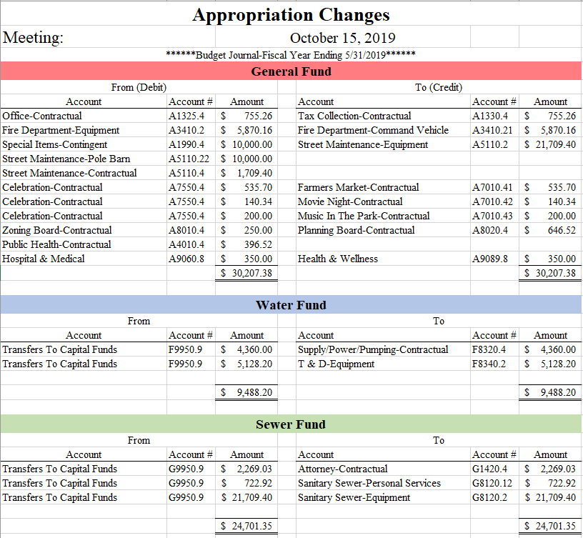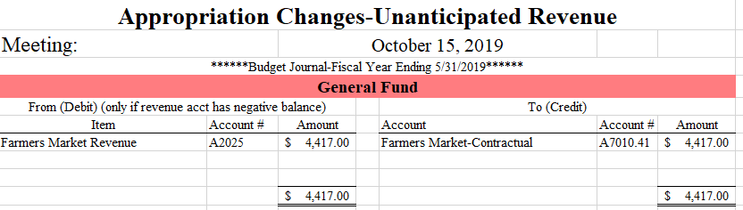
A motion to approve water/sewer adjustments from September 1-30, 2019 was made by Trustee Daoust and seconded by Trustee Ellis. Trustee Daoust voted yes. Trustee Ellis voted yes. Trustee Ringwald voted yes. The motion carried.
A motion to approve the bills on General Fund Abstract #5, vouchers 296-380 totaling $169,550.05; Water Fund Abstract #5, vouchers 97-128 totaling $ 213,675.09; Sewer Fund Abstract #5, vouchers 97-124 totaling $ 34,408.23; Capital Projects Fund Abstract #5, voucher 3 totaling $ 934,334.20; Adopt A Grave Fund Abstract #5, voucher 9 totaling $ 2,250.00; Owl Project Fund Abstract #5, voucher 4 totaling $ 112.00; Trust & Agency Fund Abstract #5, voucher 4 totaling $ 396.90 was made by Trustee Ellis and seconded by Trustee Ringwald. Trustee Daoust voted yes. Trustee Ellis voted yes. Trustee Ringwald voted yes. The motion carried.

*Voided General Fund check #18968 dated 8/12/19 in the amount of $ 3,969.34 from Abstract #3 due to a duplicate payment to Whiteman, Osterman & Hanna.

Public Comment Period

Chris Chimento asked if the Village was still within the time frame to submit the stipulations.
Terresa Bakner, of Whiteman, Osterman & Hanna, stated that the Village is still within the deadline to submit. After the comments on the stipulations are received, the applicant, Hecate Energy, will submit their application for the project within 60 days, and the Public Service Commission staff looks to see if there are any deficiencies. The Village may not hear anything regarding the project until around the end of the year. Once complete, then the public hearings will start. The hearings should be held here in the communities that are affected by the project. In this case, this means both the Village and Town.

No further public comments were offered.

A motion to adjourn the Board meeting was made by Trustee Daoust and seconded by Trustee Ringwald. Trustee Daoust voted yes. Trustee Ellis voted yes. Trustee Ringwald voted yes. The motion carried.

The meeting was adjourned at 7:25 p.m.

Respectfully submitted,

Nikki Bereznak
Clerk

