VILLAGE OF COXSACKIE
BOARD MINUTES
August 13, 2019

Mayor Mark Evans called the Board Meeting to order at 7:00 p.m. Present were Trustee Donald Daoust, Trustee Stephen Hanse and Trustee Dianne Ringwald. Trustee Joseph Ellis was absent.
A motion to approve the minutes from the July 9, 2019 Board Meeting was made by Trustee Daoust and seconded by Trustee Ringwald. Trustee Daoust voted yes. Trustee Hanse voted yes. Trustee Ringwald voted yes. The motion carried.

A motion to approve the minutes from the July 18, 2019 Special Meeting was made by Trustee Ringwald and seconded by Trustee Hanse. Trustee Daoust voted yes. Trustee Hanse voted yes. Trustee Ringwald voted yes. The motion carried.
Correspondence Received
A letter was received from the Greene County IDA advising that they are selling a parcel of land at 317 Mansion Street by sealed bid due on August 15, 2019.

A letter was received from the DEC regarding the need to start the cleanup of the gas spill at the DPW garage.

A letter was received from Shaun Groden, County Administrator, requesting to have the Village deed over the transfer station to the County, per the now expired agreement.

Correspondence Sent

A letter was sent to Ferguson thanking them for the donation of the park benches.
Liaisons & Board Reports

Mayor Evans stated that the Village Board will dispense with the reading of the monthly department head reports, but that all monthly reports are on file with the Village Clerk.
Motions & Resolutions
A motion to approve the request received from Lisa Chapman, of 100 Riverside Avenue, to authorize a payment plan and not incur penalties on her water/sewer account, so long that her balance of $3,685.14 is paid within one year and she keeps current on her new bills was made by Trustee Hanse and seconded by Trustee Ringwald. Trustee Daoust voted yes. Trustee Hanse voted yes. Trustee Ringwald voted yes. The motion carried.
A motion to approve the request received from Michael Barberi, of Mansion Street Apartments, LLC at 216 Mansion Street, asking to recalculate his water/sewer bill at the lower rate since it is not within his control that he has not had a radio read meter installed yet, and therefore should not be receiving the higher rate was made by Trustee Hanse and seconded by Trustee Ringwald. Trustee Daoust voted yes. Trustee Hanse voted yes. Trustee Ringwald voted yes. The motion carried.

A motion to approve a policy of age 21 for driving any Village owned vehicle was made by Trustee Hanse and seconded by Trustee Ringwald. Trustee Daoust voted yes. Trustee Hanse voted yes. Trustee Ringwald voted yes. The motion carried.

A motion to approve the following appropriation changes was made by Trustee Daoust and seconded by Trustee Ringwald. Trustee Daoust voted yes. Trustee Hanse voted yes. Trustee Ringwald voted yes. The motion carried.

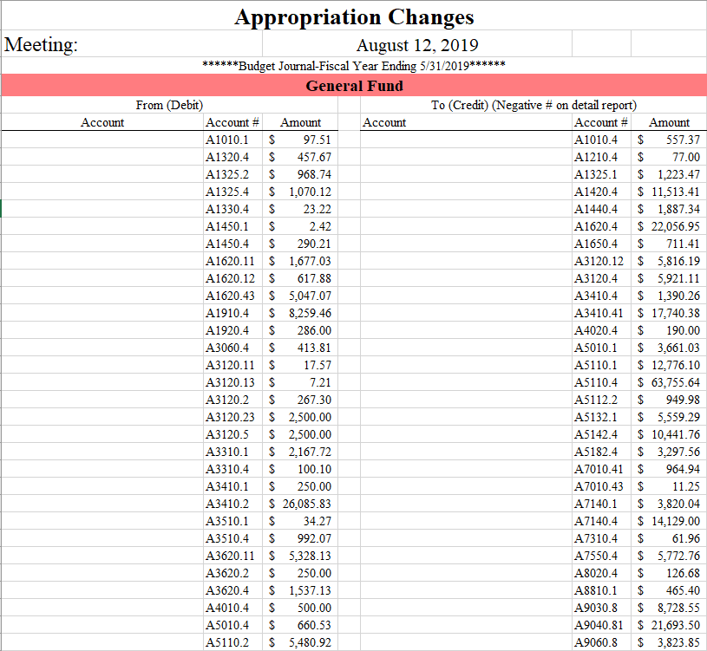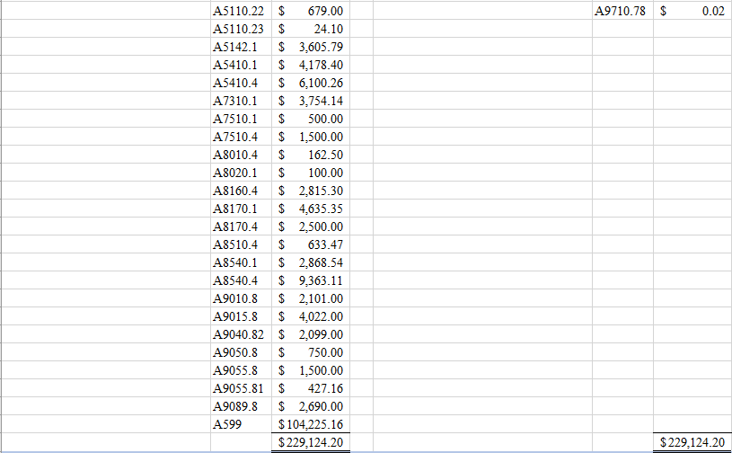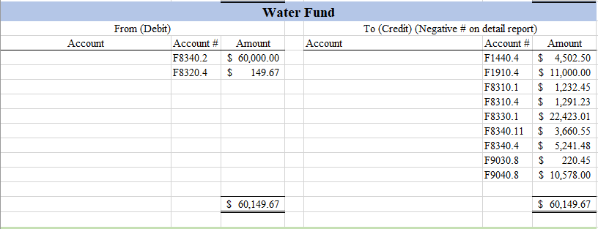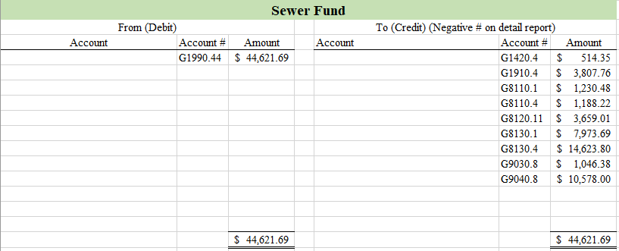
A motion to approve water/sewer adjustments from July 1-31, 2019 was made by Trustee Hanse and seconded by Trustee Ringwald. Trustee Daoust voted yes. Trustee Hanse voted yes. Trustee Ringwald voted yes. The motion carried.
A motion to approve the bills on General Fund Abstract #3, vouchers 113-217 totaling $194,841.91; Water Fund Abstract #3, vouchers 34-66 totaling $ 68,345.50; Sewer Fund Abstract #3, vouchers 34-67 totaling $ 76,188.38; Capital Projects Fund Abstract #3, voucher 1 totaling $ 208,838.66; Adopt A Grave Fund Abstract #3, voucher 8 totaling $ 12.50 was made by Trustee Ringwald and seconded by Trustee Daoust. Trustee Daoust voted yes. Trustee Hanse voted yes. Trustee Ringwald voted yes. The motion carried.

Public Comment Period

No public comments were offered.

A motion to adjourn the Board meeting was made by Trustee Hanse and seconded by Trustee Daoust. Trustee Daoust voted yes. Trustee Hanse voted yes. Trustee Ringwald voted yes. The motion carried.

The meeting was adjourned at 7:10 p.m.

Respectfully submitted,

Nikki Bereznak
Clerk

